**Experiment 10:** Create a simple cloud web application for student counselling system using any Cloud Service Provider to demonstrate SaaS with the fields of student name, age, address, phone, subjects studied, Year of passing, percentage of marks, domain interest, etc.

Step 1 : Creating a Application Form For Student Details. 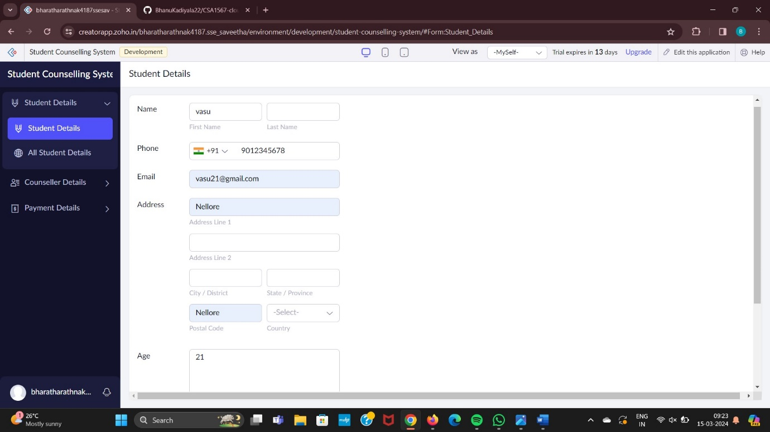

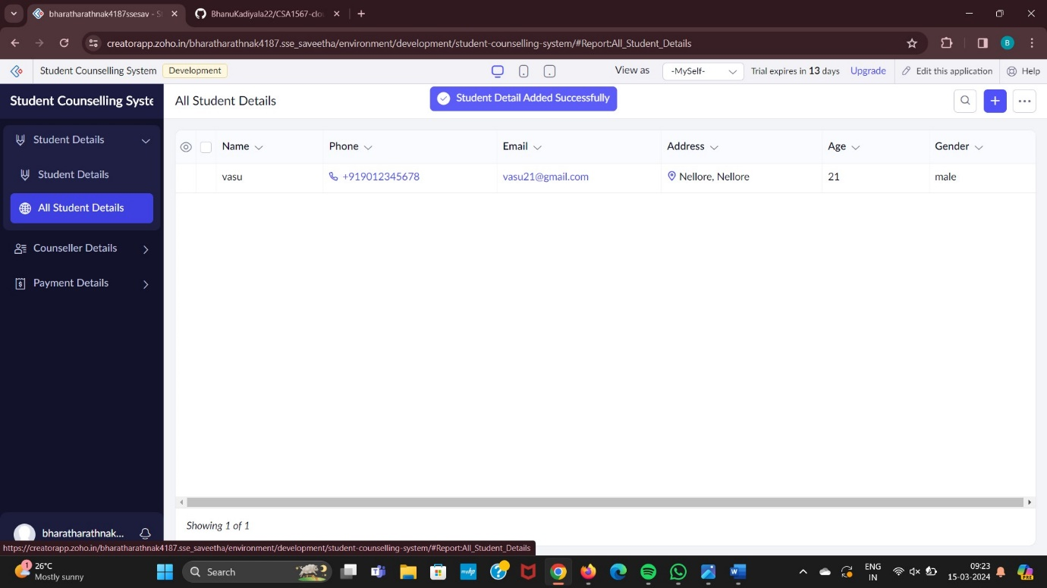

Step 2: Creating a Application Form For Counseller Details.

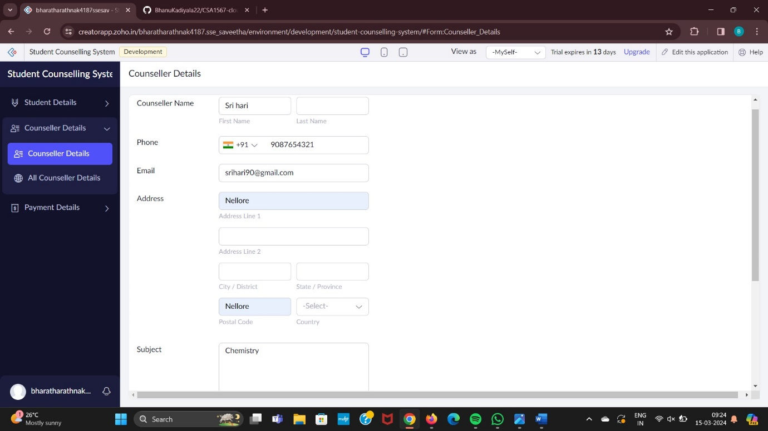

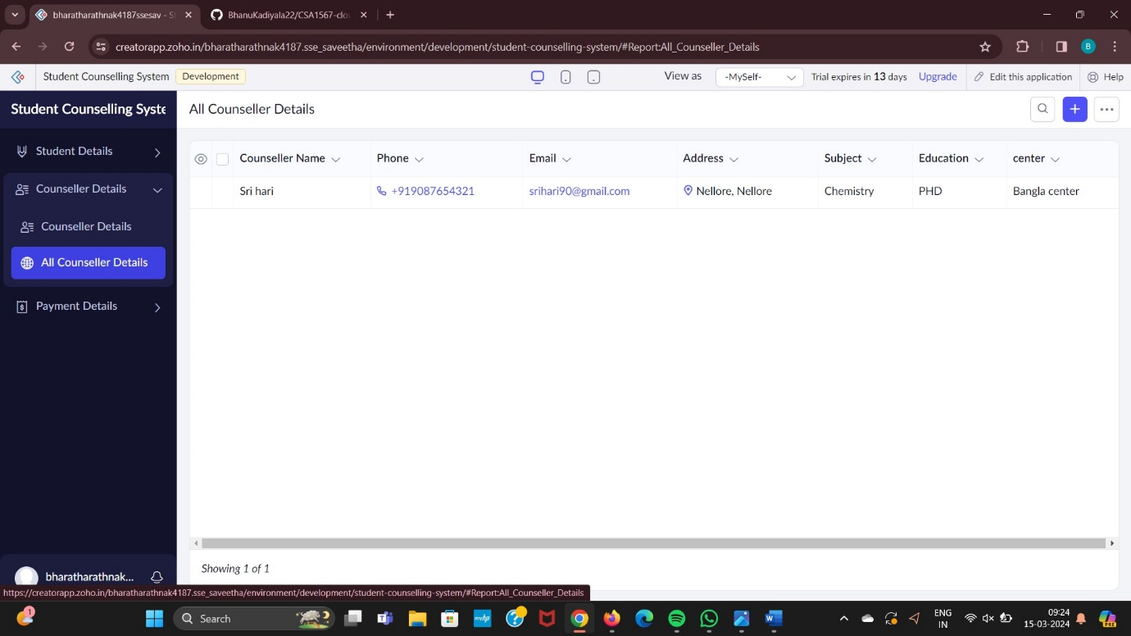

Step 3: Creating a Application Form For Payment Details.

